**Advanced Shaders Programming**

**IMAT3907**

**Leon Le – P17183692**

**Computer Games Programming**

**Module Leader: Dr Conor Fahy**



Contents

Introduction 3

Methodology 3

Terrain 3

Geometry Shader 3

Tessellation shader 4

Simplex Perlin Noise 5

Infinite terrain generation 5

Skybox 5

Framebuffer/Post-Processing 5

Shadow mapping 6

Result 6

Conclusion 8

Reference and Bibliology 9

# Introduction

In this assignment the objectives are to understand the complex concepts of advanced shader techniques. Using this knowledge to create a realistic 3D terrain with the combination of shader techniques such as tessellation, shadow mapping, framebuffers, post-processing, Perlin noise and many others.

# Methodology

In this project I will be using C++ with OpenGL programming language to implement and create the 3D terrain. I will be explaining how shader information passes through the pipeline to generate a realistic terrain. Basic shader pipelines consist of a vertex and a fragment shader. To use advanced techniques in this project, I will be implementing other shaders such as geometry shader and tessellation shader which contains two individual shaders, a control, and an evaluation shader.

## Terrain

The terrain was created on the CPU in a class. The class would need values for width, depth, and step size to be passed in to create the plane. The class would create vertices from the values and push back the information on to the stack. The height for the terrain will be created using height mapping first then later on be changed to procedural generation using Perlin noise so that infinite terrain can be generated using the seed value from simplex Perlin Noise.

The height map was created using a texture that was loaded in and then bound to the GPU which allowed for the height on the y coordinates to be displaced creating a 3D terrain. This was done on the tessellation evaluation shader. The normals was generated using the central difference method. This method takes a grid of points for up, down, left, and right from the height map and tex-coords. Each corresponding point is then subtracted from each other and normalised for example, right – left and down – up. The normals were then passed along the pipeline to improve the look of the terrain, amplifying the detail.

## Geometry Shader

The geometry shader is an optional process between the vertex and fragment shader. The geometry shader takes in a set of vertices that is used to create a single primitive which could be a point or a triangle. Normals can be created inside the geometry and passed along the pipeline.

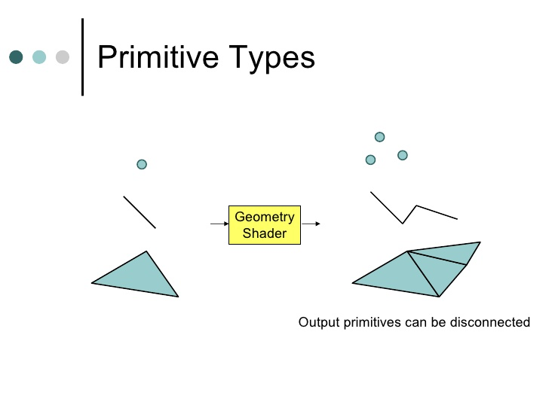

Figure Example of Geometry shader transforming vertices. [1]

The geometry shader is first set-up by declaring the type of information being sent in from the vertex shader and declaring the form of information that will be sent out to the fragment shader.

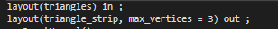

Figure 2 Geometry shader set-up taken from work

Above is an example of the geometry shader declaring that triangles will be sent in and triangle strips will be sent out. There are other primitive values that can be used for example, points, lines and lines/triangle adjacency. Other output primitives include points and line strips. The output must declare max vertices which done to define the number of maximum vertices the geometry shader would use on a single pass.

The geometry shader uses a built-in function “EmitVertex()” this is used to combine all vertices that have been set to an output render primitive. [2] If multiple “EmitVertex()” function is called it can generate multiple primitives. Another function called “EndPrimitive()” allows for a primitive to end and start a new primitive without having to emit a vertex. This can be used to create multiple shapes that are independent.

## Tessellation shader

The tessellation shader is made up of three parts, the tessellation control shader, tessellation primitive generator and tessellation evaluation shader. In the shader pipeline they would sit between the vertex and geometry shader.

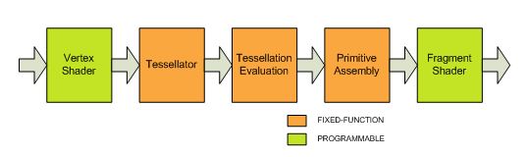

Figure 3 Simplified rendering pipeline [3]

The tessellation shader’s purpose is to amplify detail on a modelled object by dividing the mesh of the model into sections of triangles. The vertices the mesh can then be manipulated to create additional geometry to the modelled object.

The tessellation control shader is used to define the amount of tessellation the primitive should have, addition to having the ability to transform the data that has been passed into the tessellation control shader. This means the tessellation control shader can increase geometry of a model and manipulate the mesh of that model. This will be very useful for generating a height map for terrain.

The tessellation primitive generator is a fixed function stage after the tessellation control shader, it is not programmable and is responsible for generating the new vertices inside the patch. [5]

The tessellation evaluation shader takes the coordinates produced by the primitive generator with the output of the tessellation control shader and combines them to process the new values for the vertices. Also, this shader allows for coding of an algorithm to generate new positions, normal and tex-coords. [6] The information is then passed onto the fragment shader or geometry if used.

Tessellation allow for rendering of more detail on the terrain when the camera was closer and decreased detail when further away.

## Simplex Perlin Noise

The terrain was first created using height mapping. The information from the texture was passed from the height map into the tessellation shader and added to the y coordinates to create height on the 3D terrain. This technique was changed out for the use of Perlin noise as my objective was to procedural generate infinite terrain.

The process to create terrain using simplex Perlin noise could be done on either the CPU or GPU, in this case I used the GPU. The first step was to create a function inside the tessellation shader that allowed for random number to be created using the system time. The random number was passed to an algorithm to create simplex Perlin noise, another function would cycle through multiple octaves to create a more realistic like terrain this was done by multiplying the Perlin noise with an amplitude and adding it to the total. The way this works is that each octave creates a wave made by the noise, the waves would be added together to create more natural bumps, that would be applied to the y coordinates on the terrain.

## Infinite terrain generation

To create infinite terrain, I would first have to modify the terrain class. A new function was created to check if the camera was out of the terrain’s boundaries. Using an If statement in the source file the camera’s position was checked against a given distance between terrain edge. If the outcome was true new values for the terrain and vertices were given. The buffers were also reassigned and rendered. Another if statement would check whether this was active or not, this was to stop an issue with multiple instances of generating new terrain.

## Skybox

To add more detail to the project a skybox was implemented. The skybox is made by creating a cube model and attracting six different textures onto each size of the cube. A skybox class was created to store the cube vertices along with setting up the vertex array, and buffer data. A separate shader was made for the skybox to pass the tex-coords, view and projection onto the GPU. The skybox was the last object to be rendered as the depth test and view had to be altered.

## Framebuffer/Post-Processing

In order to implement shadow mapping, I had to use framebuffers. Framebuffers is a technique that is mainly used to add post-processing effects to the already rendered scene. There are a variety of different effects that can be created by framebuffers:

* Shadows
* Mirror effect
* Bloom/HDR (high dynamic range)
* Fog
* Night-vision
* Water effects

Framebuffers are like any other OpenGL buffer, so the first step was to create a framebuffer object and bind it as the active framebuffer. An attachment must be used along with framebuffers in order for framebuffers to work. There are four buffer attachments:

* Colour
* Depth
* Stencil
* Depth and stencil

In this project only colour and depth buffer were used because colour allowed for the change in different colour effects and depth allowed fog and shadows. Both colour and depth buffers are set-up similarly, both buffer objects need to be created and bind. Both buffers need to create a texture and allocate space. After, the texture is bound to the framebuffer and a render buffer object is created and bound to the framebuffer. The render buffer object is used to optimise off screen rendering making the process faster. Unbinding the framebuffer is done at the end.

For this process to work a first pass in the main loop is made, this first pass binds the created framebuffer and contains the render scene using the main shader. The second pass is where the default framebuffer is used and the post processing shader is active to apply effects onto the created texture that is then placed onto a rectangle object that will cover the rendered scene. The rectangle is a 2D object created to hold the texture which is used to display the post-processing effects.

## Shadow mapping

After the framebuffers were implemented, my next step was to create shadows, this was done by modifying the depth map framebuffer and implementing bling phong for the light source. In the depth map I changed the resolution of the texture from screen resolution to new values for shadows.

After a new projection was made using the orthographic perspective along with a new view to create a light matrix that would be passed into a new shader and the main shader. The light matrix was used in an algorithm inside the main fragment shader to calculate and create the shadows that are then added to the frag colour.

Like post-processing, shadow mapping have a first and second pass, before the first pass the terrain is created and rendered, the first pass sets the depth map framebuffer, changes the view port to the shadow resolution, calls the shadow shader and renders the scene. The second pass sets the default framebuffer, changes the view port back to normal and calls the main shader, binds the textures needed and renders the scene.

# Result

In this section I will be showing the outcome of all the techniques, the different visual looks and any issues that happened when implementing.

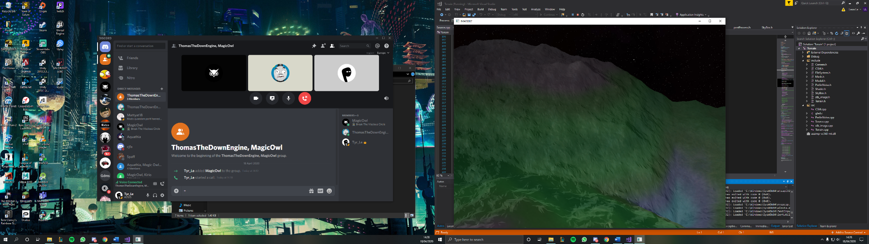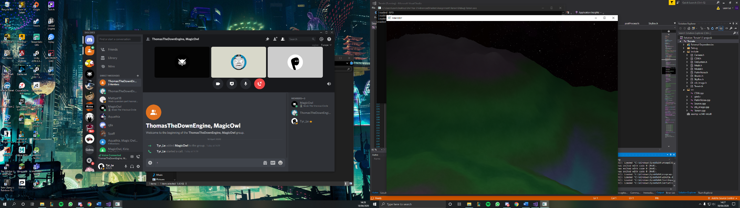

Figure 4 Left image is terrain with only colour and right image is terrain with shadows.

The left image shows the terrain with only colours and blind phong. The right image shows the shadows like implemented on top of the left image. Not perfect shadows unfortunately.

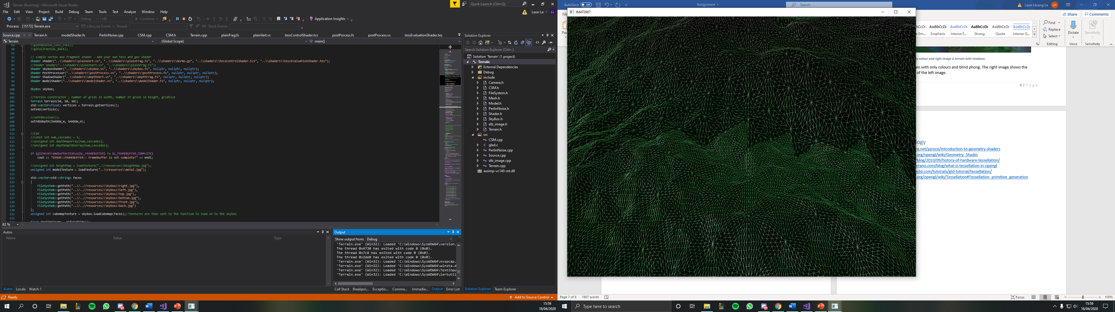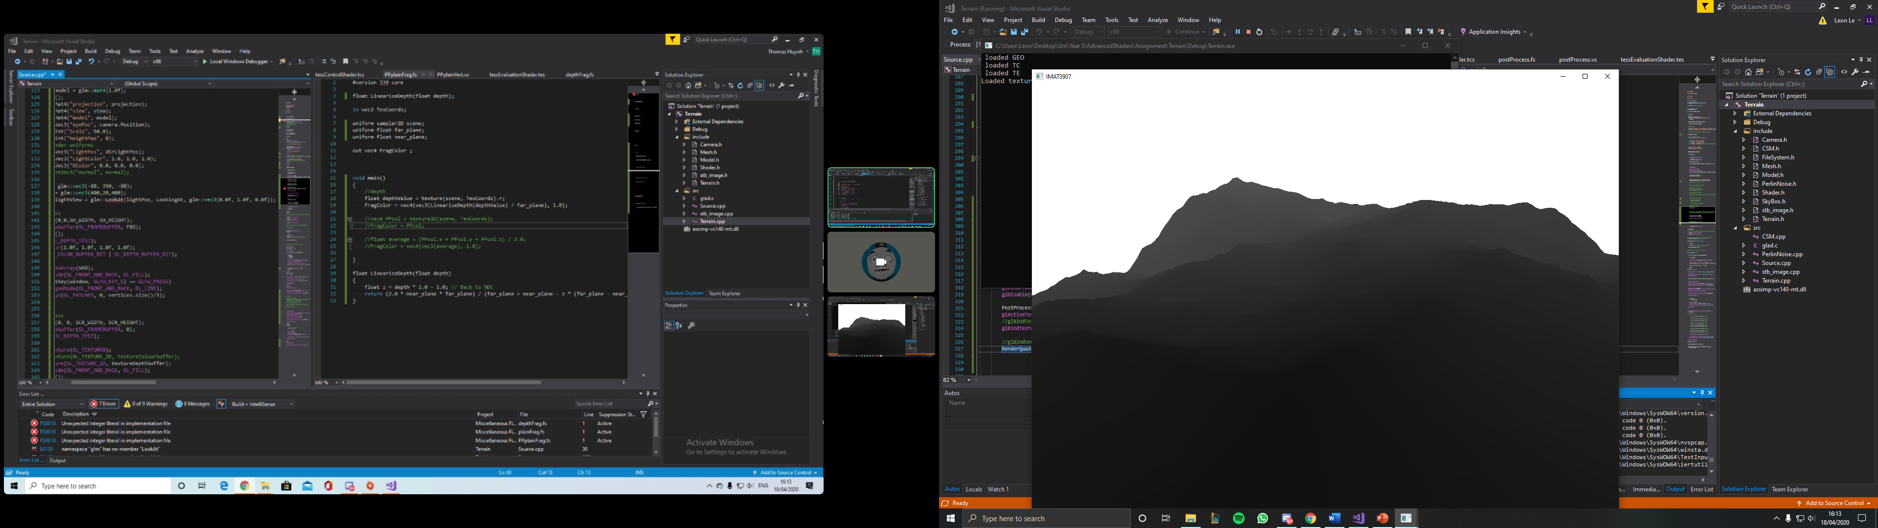

Figure 5 Left image is tessellation and right image is post-processing fog effect using depth buffer

As you can see in figure 5 the tessellation level is increased when the camera is closer. As for the right image that is a fog effect added to the terrain using post-processing.

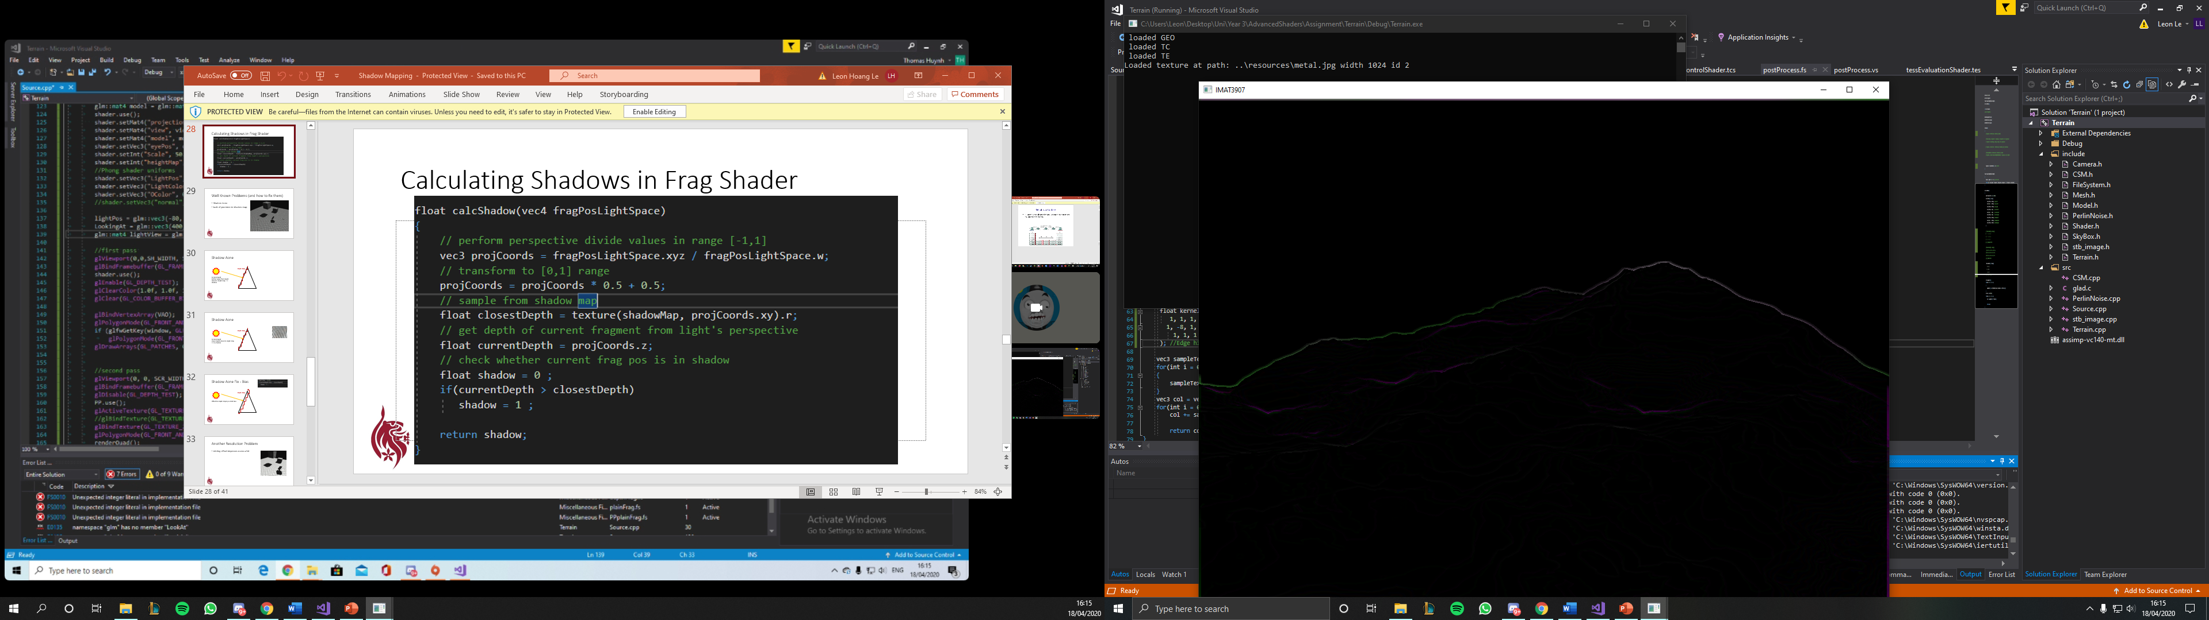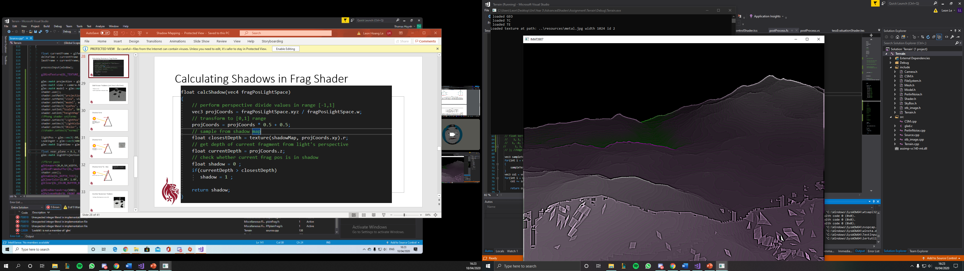

Figure 5 Both images are colour effects added using post-processing, left is edge highlight and right is sharpened effect.

Both effects are done in the post processing shader using a set kernel function. Changing the kernel values will change the effects. Was able to turn post-processing effect on with key press “R”. Colour effect is displayed but once released it will cause the screen to tear, this was fixed by rendering the scene more than once.

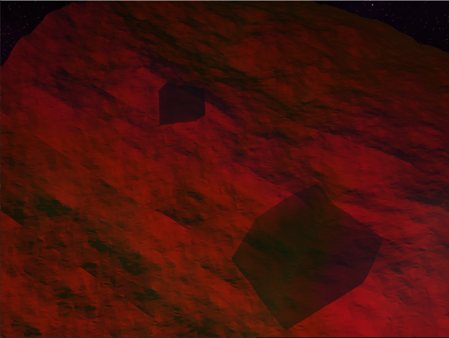

Figure shadow from cube but no cube

The image above shows shadows of the cubes but the terrain colours were altered and the cube were not appearing in the world space.

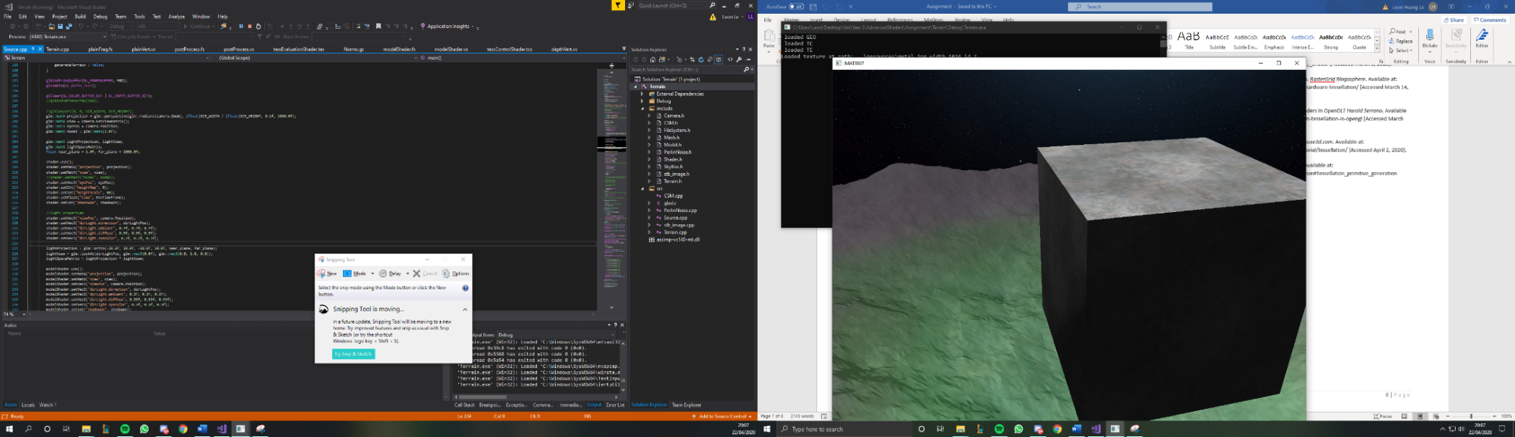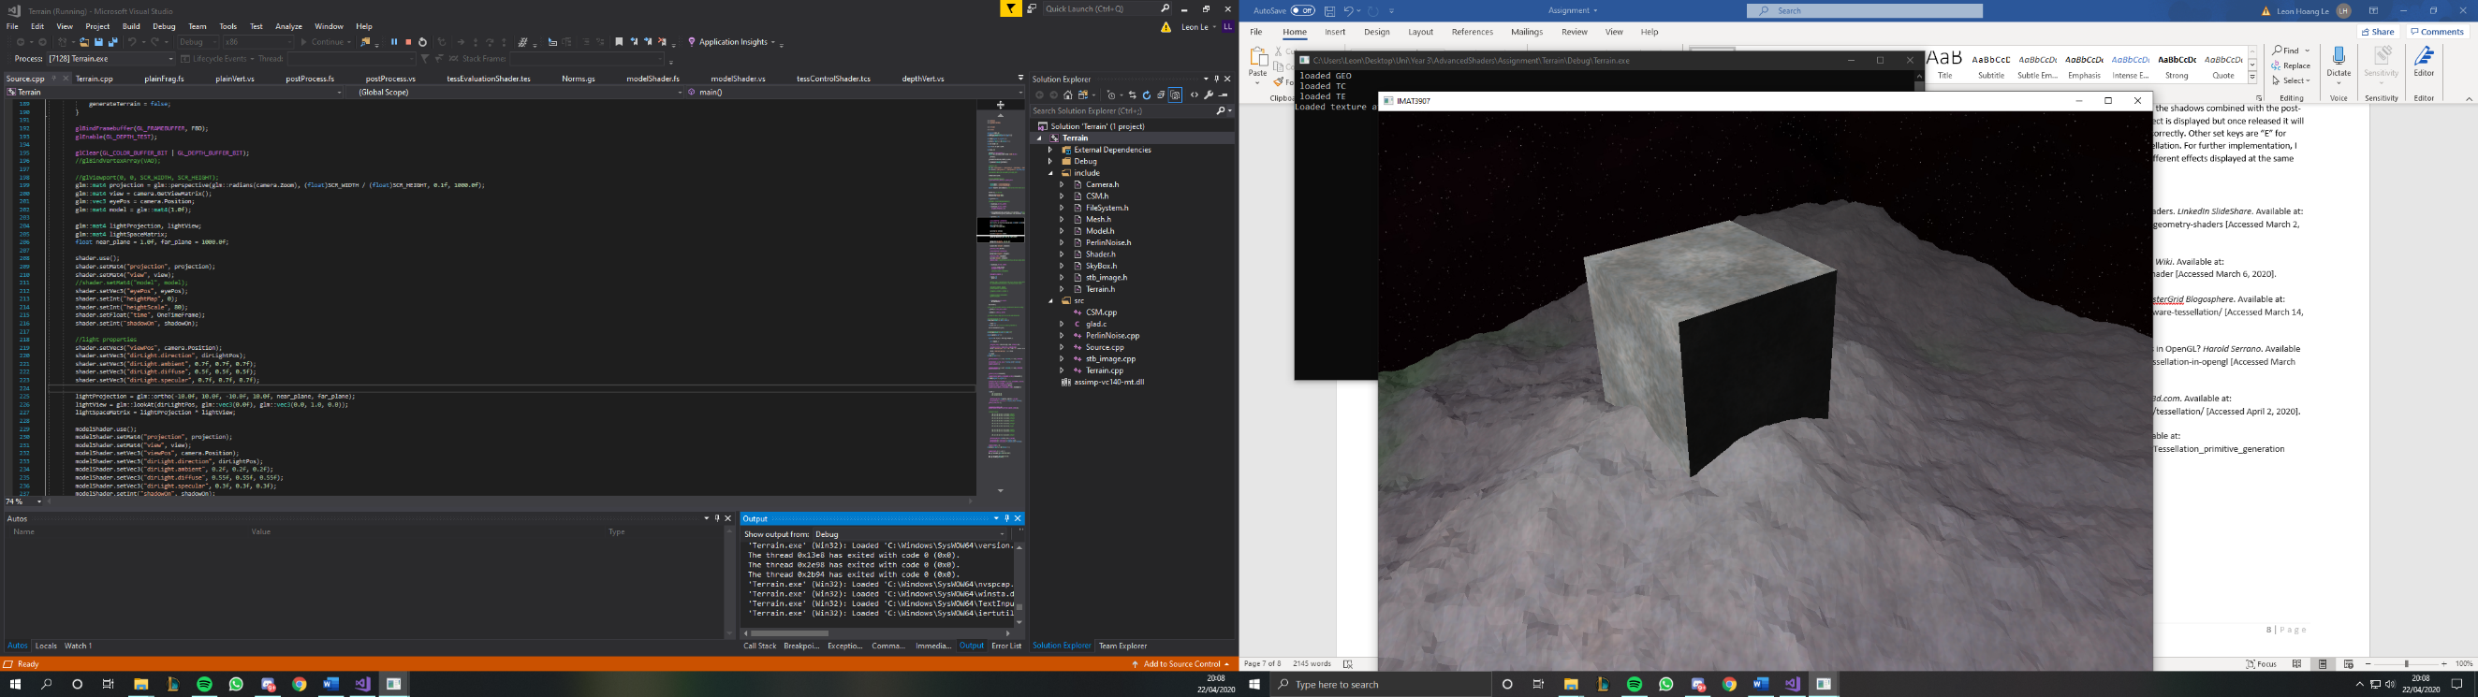

Figure Images of cube with shadow effect but no shadow on terrain from the cubes

I was unable to apply the cubes shadow onto the terrain but was able to cast a slight shadow effect on the cube itself. The issue was that the terrain main shader was changing the height of the cube when using the main shader because of the Perlin noise. So instead I chose to create a new shader for the cube and try cast the shadows from the cube onto the terrain by passing both the cube from the main shader, shadow shader and model shader.

The image above shows shadows displaying from the cube onto the terrain with an issue on the left image but was later resolved in the image on the right by removing shadows calculation from the model shader.

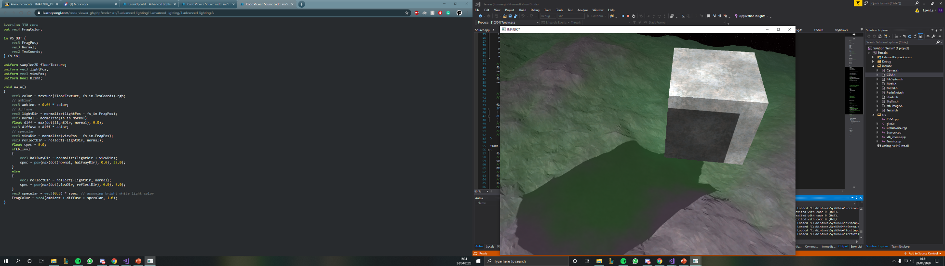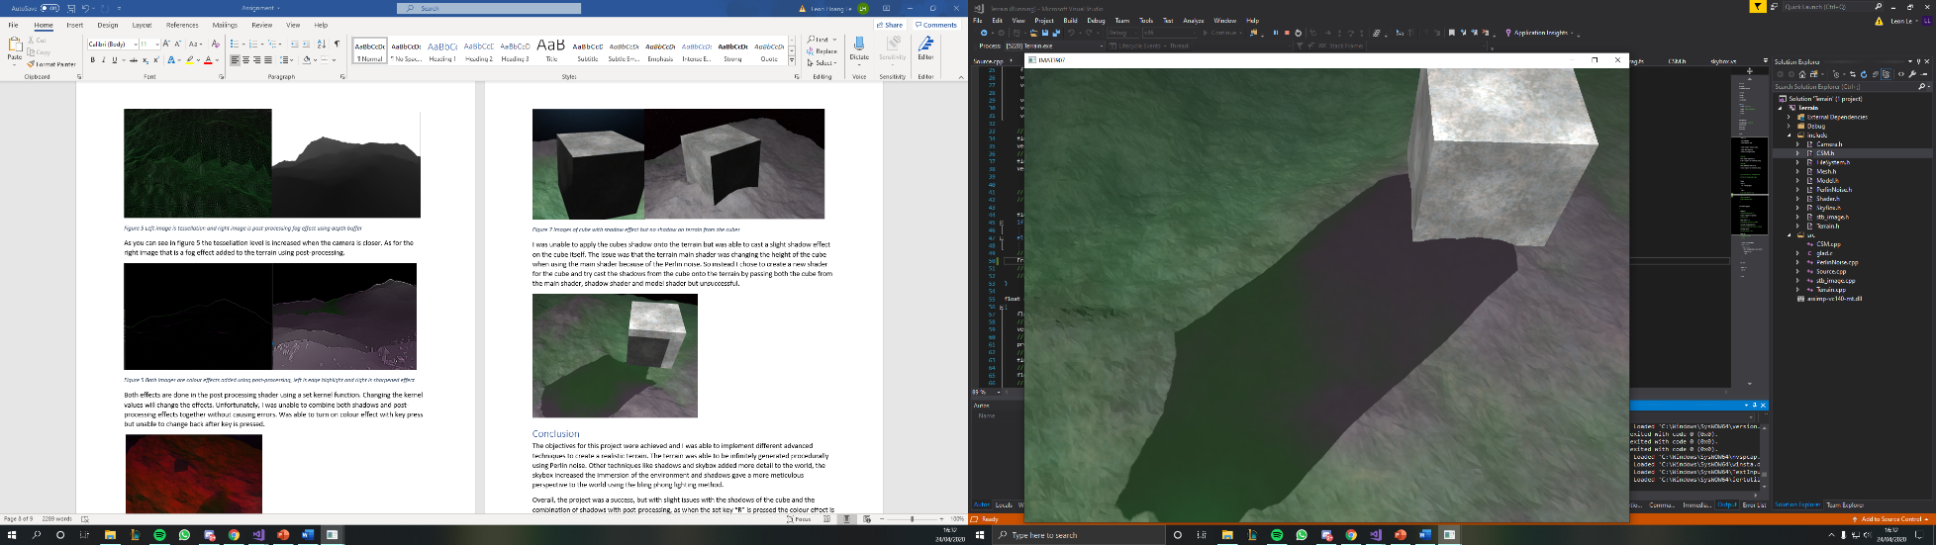

Figure 8 shadow display on top of cube and issue resolved in right image

# Conclusion

Most of the objectives for this project were achieved and I was able to implement different advanced techniques to create a realistic terrain. The terrain was able to be infinitely generated procedurally using Perlin noise. Other techniques skybox added more detail to the world, the skybox increased the immersion of the environment and shadows was not perfect but gave a more meticulous perspective to the world using the bling phong lighting method.

Overall, the project was a success, but with a slight issue with the shadows of the terrain as it would not display shadows cast from terrain onto other terrain. Set keys are “E” for disabling shadows, “F” to display wireframe to view tessellation and “R” to display post-processing. For further implementation, I would have liked to enable multiple camera views to have different effects displayed at the same time.

# Reference and Bibliology

1. P.J.Cozzi Follow, 2009. Introduction To Geometry Shaders. *LinkedIn SlideShare*. Available at: https://www.slideshare.net/pjcozzi/introduction-to-geometry-shaders [Accessed March 2, 2020].
2. Anon, Geometry Shader. *Geometry Shader - OpenGL Wiki*. Available at: https://www.khronos.org/opengl/wiki/Geometry_Shader [Accessed March 6, 2020].
3. Rákos, D., 2019. History of hardware tessellation. *RasterGrid Blogosphere*. Available at: http://rastergrid.com/blog/2010/09/history-of-hardware-tessellation/ [Accessed March 14, 2020].
4. Harold Serrano, 2015. What are Tessellation Shaders in OpenGL? *Harold Serrano*. Available at: https://www.haroldserrano.com/blog/what-is-tessellation-in-opengl [Accessed March 22, 2020].
5. Anon, 2015. GLSL Tutorial – Tessellation. *Lighthouse3d.com*. Available at: http://www.lighthouse3d.com/tutorials/glsl-tutorial/tessellation/ [Accessed April 2, 2020].
6. Anon, Tessellation. *Tessellation - OpenGL Wiki*. Available at: https://www.khronos.org/opengl/wiki/Tessellation#Tessellation_primitive_generation [Accessed April 3, 2020].